# NEPR 2017-07: Abrasion Test Protocols

## Sample Preparation

Take a set sample and cut at least two 100 x 100mm samples. Use at least one for testing and one for a weight control.

## Sample Naming System

NOTE: there need be no distinction between MD or TD as samples are square and tested on a rotating machine.

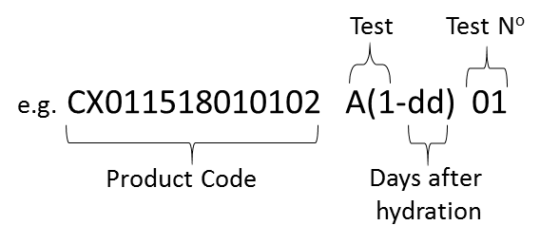

## Data Export

The results sheet should be forwarded to Marcin to calculate the abrasion rate. Marcin will take responsibility for calculating the abrasion rate and archiving the data.

## Product Structure

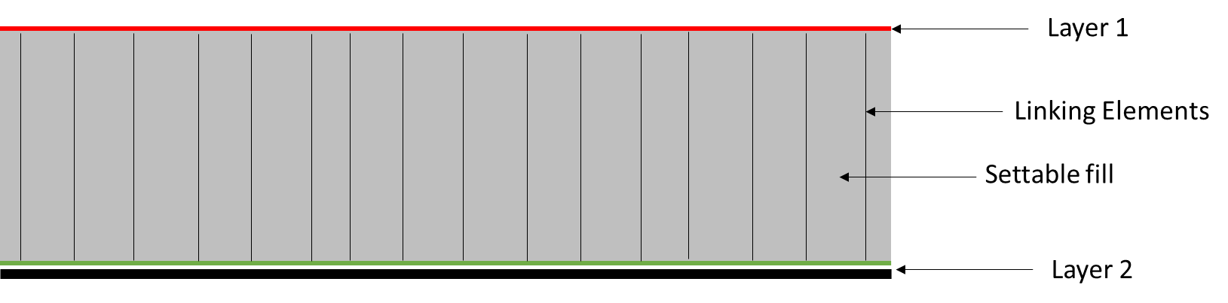

NOTE: Layers 1 and/or 2 can be a composite of a number of individual elements, such as fibre donor, keying, impervious and reinforcement elements.

Abrasion Test Protocols

|  |  |
| --- | --- |
| A(1-dd) Standard set sample test with Layer 1 on the top |  |
| A(2-dd) Standard set sample test with Layer 2 on the top |  |